Functional Model
By
Sairam Pendem

1. Use Case diagram
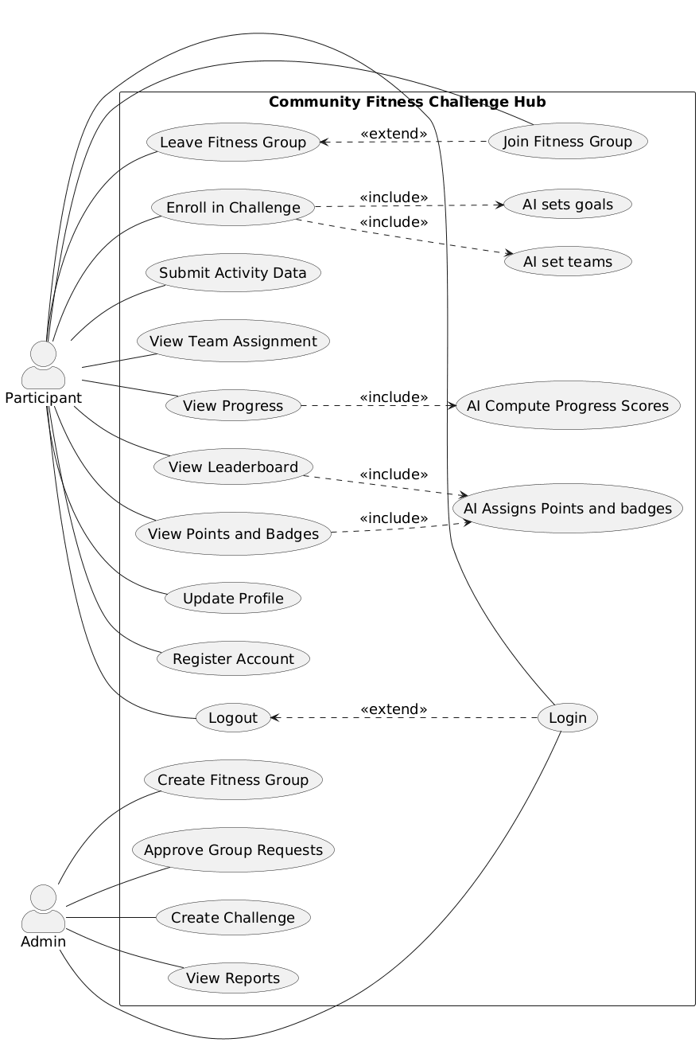
Figure.1 Use Case Diagram

Child Use-Case Diagram – AI Engine (Community Fitness Challenge Hub)
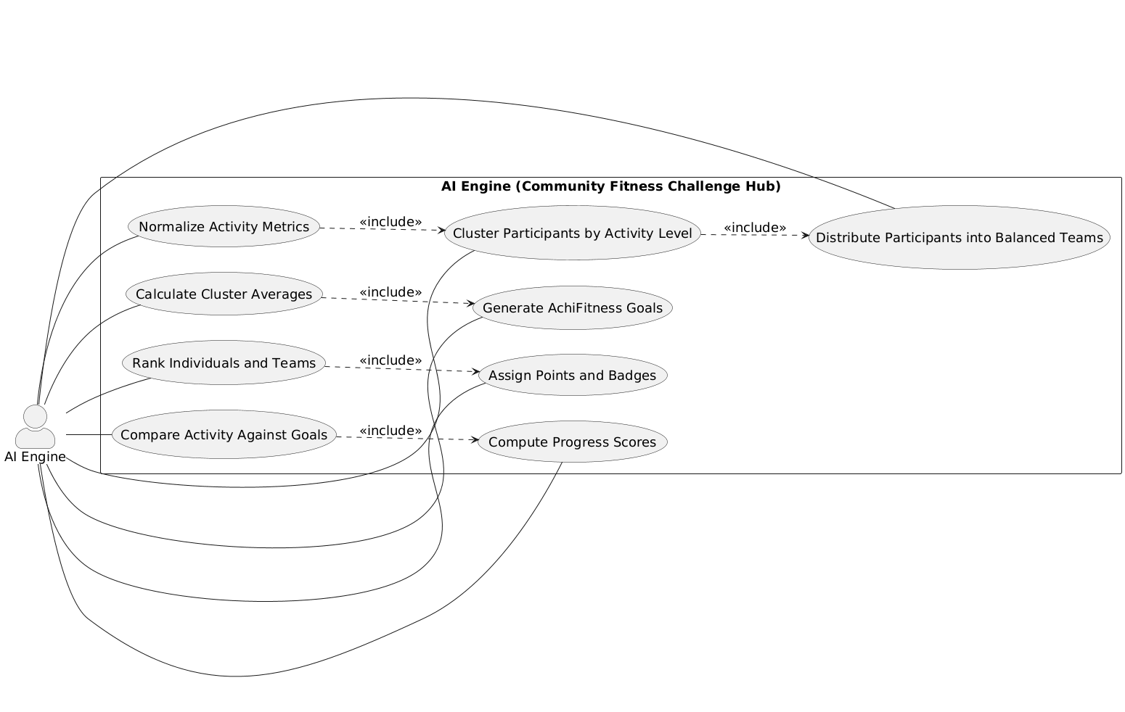
Figure.2 Child Use-Case Diagram – AI Engine (Community Fitness Challenge Hub)

2. Use Case Description

Use Case 1 – Register Account
Use Case Number | 1
Use Case Name | Register Account
Primary Actor | Participant
Stakeholders | Participant, Admin
Description | Allows a new participant to create an account.
Preconditions | User is not registered; system is available.
Trigger | Participant selects Register option.
Main Flow | 1. System shows registration form.  2. Participant enters details.  3. System validates input.  4. System creates account.  5. System confirms registration.
Alternate / Exception Flows | If details are invalid or email exists, show error.
Postconditions | Account is created and stored.
Related User Requirement(s) | Participant can create user account in system.

Use Case 2 – Login
Use Case Number | 2
Use Case Name | Login
Primary Actor | Participant, Admin
Stakeholders | Participant, Admin
Description | Allows a registered user to access the system features.
Preconditions | User account exists. System is available.
Trigger | User selects the Login option from the home page.
Main Flow | 1. System displays login form.  2. User enters username and password.  3. System checks credentials.  4. System verifies account status.  5. System creates a user session.  6. System redirects user to dashboard.
Alternate / Exception Flows | 3a. Invalid credentials → system shows error.  4a. Account locked → system blocks access.  4b. Network issue → system asks to retry.
Postconditions | User is logged in. Session is active.
Related User Requirement(s) | Admin can log in. Participant can log in.

Use Case 3 – Logout
Use Case Number | 3
Use Case Name | Logout
Primary Actor | Participant, Admin
Stakeholders | Participant, Admin
Description | Ends the current user session safely.
Preconditions | User is logged in.
Trigger | User selects the Logout option.
Main Flow | 1. System receives logout request.  2. System invalidates session token.  3. System clears session data.  4. System redirects user to home page.
Alternate / Exception Flows | 2a. Session expired → system logs out automatically.  3a. Network issue → system retries logout.
Postconditions | User is logged out. Session is closed.
Related User Requirement(s) | Admin can log out. Participant can log out.

Use Case 4 – Join Fitness Group
Use Case Number | 4
Use Case Name | Join Fitness Group
Primary Actor | Participant
Stakeholders | Participant, Admin
Description | Sends a request to join a selected fitness group.
Preconditions | User is logged in. Group exists.
Trigger | User selects a fitness group and clicks Join.
Main Flow | 1. System displays available groups.  2. User selects a group.  3. System submits join request.  4. System notifies admin.  5. System marks request as pending.
Alternate / Exception Flows | 3a. Group is full → system shows message.  3b. Request already sent → system blocks duplicate.
Postconditions | Join request is recorded.
Related User Requirement(s) | Participant can request access to private fitness group.

Use Case 5 – Leave Fitness Group
Field | Details
Use Case Number | 5
Use Case Name | Leave Fitness Group
Primary Actor | Participant
Stakeholders | Participant, Admin
Description | Removes the participant from a fitness group.
Preconditions | User is a member of a group.
Trigger | User selects Leave Group option.
Main Flow | 1. System shows confirmation message.  2. User confirms leave.  3. System removes user from group.  4. System updates group member list.  5. System updates user dashboard.
Alternate / Exception Flows | 2a. User cancels → no change made.  3a. Server error → system retries update.
Postconditions | User is no longer a group member.
Related User Requirement(s) | Participant can leave fitness group.

Use Case 6 – Enroll in Challenge
Use Case Number | 6
Use Case Name | Enroll in Challenge
Primary Actor | Participant
Stakeholders | Participant, Admin
Description | Registers the participant into an active challenge.
Preconditions | User is logged in. User is in a group. Challenge is active.
Trigger | User selects Enroll on a challenge.
Main Flow | 1. System displays active challenges.  2. User selects a challenge.  3. System registers user.  4. System triggers AI set teams.  5. System triggers AI sets goals.  6. System confirms enrollment.
Alternate / Exception Flows | 2a. Challenge closed → system shows message.  3a. Already enrolled → system blocks action.
Postconditions | User is enrolled in the challenge.
Related User Requirement(s) | Participant can enroll in fitness challenge.

Use Case 7 – Submit Activity Data
Use Case Number | 7
Use Case Name | Submit Activity Data
Primary Actor | Participant
Stakeholders | Participant, System
Description | Records daily activity for the challenge.
Preconditions | User is logged in. User is enrolled in a challenge.
Trigger | User selects Submit Activity option.
Main Flow | 1. System shows activity form.  2. User enters steps or minutes.  3. User selects activity type.  4. System validates input values.  5. System saves activity data.  6. System updates activity history.
Alternate / Exception Flows | 2a. Missing values → system shows error.  4a. Invalid numbers → system asks to correct.  5a. Save fails → system retries.
Postconditions | Activity data is stored in the system.
Related User Requirement(s) | Participant can submit activity data.

Use Case 8 – View Team Assignment
Use Case Number | 8
Use Case Name | View Team Assignment
Primary Actor | Participant
Stakeholders | Participant
Description | Shows the team assigned to the participant.
Preconditions | User is enrolled in a challenge. Teams are created.
Trigger | User selects View Team option.
Main Flow | 1. System retrieves team data.  2. System displays team name.  3. System displays team members.  4. System displays team goal.
Alternate / Exception Flows | 1a. Teams not ready → system shows pending message.
Postconditions | Team information is displayed to user.
Related User Requirement(s) | Participant can view team assignment.

Use Case 9 – View Progress
Use Case Number | 9
Use Case Name | View Progress
Primary Actor | Participant
Stakeholders | Participant
Description | Shows personal and team progress.
Preconditions | User is enrolled. Activity data exists.
Trigger | User selects View Progress option.
Main Flow | 1. System collects activity data.  2. System triggers AI Compute Progress Scores.  3. System calculates completion percent.  4. System displays personal progress.  5. System displays team progress.
Alternate / Exception Flows | 1a. No activity data → system shows zero progress.
Postconditions | Progress metrics are displayed.
Related User Requirement(s) | Participant can view progress metrics.

Use Case 10 – View Leaderboard
Use Case Number | 10
Use Case Name | View Leaderboard
Primary Actor | Participant
Stakeholders | Participant
Description | Displays current rankings.
Preconditions | User is enrolled. Rankings exist.
Trigger | User selects View Leaderboard.
Main Flow | 1. System retrieves ranking data.  2. System sorts by score.  3. System displays top participants.  4. System displays team rankings.
Alternate / Exception Flows | 1a. Rankings not ready → system shows loading message.
Postconditions | Leaderboard is displayed.
Related User Requirement(s) | Participant can view leaderboard results.

Use Case 11 – View Points and Badges
Use Case Number | 11
Use Case Name | View Points and Badges
Primary Actor | Participant
Stakeholders | Participant
Description | Shows rewards earned by the user.
Preconditions | User is enrolled. Rewards are assigned.
Trigger | User selects View Points and Badges.
Main Flow | 1. System retrieves reward data.  2. System displays points total.  3. System displays earned badges.  4. System shows reward history.
Alternate / Exception Flows | 1a. No rewards → system shows empty state.
Postconditions | Rewards are displayed to user.
Related User Requirement(s) | Participant can view earned points and badges.

Use Case 12 – Update Profile
Use Case Number | 12
Use Case Name | Update Profile
Primary Actor | Participant
Stakeholders | Participant
Description | Updates user profile details.
Preconditions | User is logged in.
Trigger | User selects Edit Profile option.
Main Flow | 1. System shows profile form.  2. User edits name or preferences.  3. User saves changes.  4. System validates inputs.  5. System stores updated data.  6. System confirms update.
Alternate / Exception Flows | 2a. Invalid values → system shows error.  4a. Save fails → system retries.
Postconditions | Profile information is updated.
Related User Requirement(s) | Participant can update personal profile information.

Use Case 13 – Create Fitness Group
Use Case Number | 13
Use Case Name | Create Fitness Group
Primary Actor | Admin
Stakeholders | Admin, Participants
Description | Creates a new private fitness group.
Preconditions | Admin is logged in.
Trigger | Admin selects Create Group option.
Main Flow | 1. System shows group form.  2. Admin enters group name.  3. Admin sets group settings.  4. Admin submits form.  5. System creates group record.  6. System confirms group creation.
Alternate / Exception Flows | 2a. Duplicate name → system shows error.  5a. Save fails → system retries.
Postconditions | New fitness group is created.
Related User Requirement(s) | Admin can create private fitness group.

Use Case 14 – Approve Group Requests
Use Case Number | 14
Use Case Name | Approve Group Requests
Primary Actor | Admin
Stakeholders | Admin, Participants
Description | Reviews and manages join requests.
Preconditions | Admin is logged in. Requests exist.
Trigger | Admin opens pending requests list.
Main Flow | 1. System shows pending requests.  2. Admin reviews each request.  3. Admin approves or denies.  4. System updates request status.  5. System notifies participant.
Alternate / Exception Flows | 1a. No requests → system shows message.
Postconditions | Request is approved or denied.
Related User Requirement(s) | Admin can approve or deny access requests.

Use Case 15 – Create Challenge
Use Case Number | 15
Use Case Name | Create Challenge
Primary Actor | Admin
Stakeholders | Admin, Participants
Description | Creates a new fitness challenge for a group.
Preconditions | Admin is logged in. Group exists.
Trigger | Admin selects Create Challenge option.
Main Flow | 1. System shows challenge form.  2. Admin enters challenge details.  3. Admin sets dates and goals.  4. Admin publishes challenge.  5. System notifies group members.
Alternate / Exception Flows | 3a. Invalid dates → system shows error.  4a. Save fails → system retries.
Postconditions | Challenge is created and visible.
Related User Requirement(s) | Admin can create fitness challenge for group.

Use Case 16 – View Reports
Field | Details
Use Case Number | 16
Use Case Name | View Reports
Primary Actor | Admin
Stakeholders | Admin
Description | Displays participation and performance reports.
Preconditions | Admin is logged in. Report data exists.
Trigger | Admin selects View Reports option.
Main Flow | 1. System collects report data.  2. System generates summary report.  3. System displays charts and metrics.  4. Admin reviews results.
Alternate / Exception Flows | 1a. No data → system shows empty report.
Postconditions | Reports are displayed to admin.
Related User Requirement(s) | Admin can view participation statistics and summaries.

Use Case 17 – AI set teams
Field | Details
Use Case Number | 17
Use Case Name | AI set teams
Primary Actor | System (AI)
Stakeholders | Participants, Admin
Description | Forms balanced teams for a challenge.
Preconditions | Users are enrolled in a challenge.
Trigger | Enrollment period ends.
Main Flow | 1. System collects participant data.  2. AI groups users by activity level.  3. AI distributes users into teams.  4. System saves team assignments.  5. System makes teams visible to users.
Alternate / Exception Flows | 2a. Low participants → create smaller teams.  3a. Data missing → use default grouping.
Postconditions | Balanced teams are created.
Related User Requirement(s) | System assigns participants to balanced teams.

Use Case 18 – AI sets goals
Use Case Number | 18
Use Case Name | AI sets goals
Primary Actor | System (AI)
Stakeholders | Participants
Description | Assigns fair goals to teams and users.
Preconditions | Teams exist.
Trigger | Teams are created.
Main Flow | 1. System reads team composition.  2. AI reviews past activity.  3. AI sets goal targets.  4. System saves goals.  5. System shows goals to users.
Alternate / Exception Flows | 2a. No history → use default goals.  3a. Outliers detected → adjust targets.
Postconditions | Fitness goals are assigned.
Related User Requirement(s) | System sets fair and achievable goals.

Use Case 19 – AI Compute Progress Scores
Use Case Number | 19
Use Case Name | AI Compute Progress Scores
Primary Actor | System (AI)
Stakeholders | Participants
Description | Computes progress scores from activity data.
Preconditions | Activity data exists. Goals exist.
Trigger | User views progress.
Main Flow | 1. System retrieves activity records.  2. AI compares data with goals.  3. AI calculates completion scores.  4. System updates score records.
Alternate / Exception Flows | 1a. No data → score set to zero.  2a. Calculation error → retry.
Postconditions | Progress scores are updated.
Related User Requirement(s) | System evaluates progress and calculates completion.

Use Case 20 – AI Assigns Points and badges
Use Case Number | 20
Use Case Name | AI Assigns Points and badges
Primary Actor | System (AI)
Stakeholders | Participants
Description | Assigns points and badges based on scores.
Preconditions | Progress scores exist. Rankings exist.
Trigger | Leaderboard or rewards are requested.
Main Flow | 1. System reads ranking results.  2. AI assigns points.  3. AI assigns badges.  4. System saves reward data.  5. System displays rewards to users.
Alternate / Exception Flows | 2a. Ties → apply tie rule.  3a. No ranking → delay rewards.
Postconditions | Points and badges are assigned.
Related User Requirement(s) | System awards points and assigns badges.

Use Case 21 – Normalize Activity Metrics
Use Case Number | 21
Use Case Name | Normalize Activity Metrics
Primary Actor | AI Engine
Stakeholders | System
Description | Normalizes raw activity values.
Preconditions | Raw activity data exists.
Trigger | New activity data is received.
Main Flow | 1. AI reads raw values.  2. AI converts units.  3. AI scales values.  4. AI removes outliers.  5. System stores normalized data.
Alternate / Exception Flows | 2a. Invalid values → discard record.
Postconditions | Clean activity data is ready.
Related User Requirement(s) | System normalizes activity data.

Use Case 22 – Cluster Participants by Activity Level
Use Case Number | 22
Use Case Name | Cluster Participants by Activity Level
Primary Actor | AI Engine
Stakeholders | System
Description | Groups participants by activity level.
Preconditions | Normalized activity data exists.
Trigger | Start clustering process.
Main Flow | 1. AI reads normalized data.  2. AI identifies activity patterns.  3. AI assigns cluster labels.  4. System stores cluster results.  5. System prepares data for team formation.
Alternate / Exception Flows | 2a. Low data → use default cluster.  3a. Clustering error → retry.
Postconditions | Participant clusters are created.
Related User Requirement(s) | System groups participants into activity clusters.

Use Case 23 – Distribute Participants into Balanced Teams
Use Case Number | 23
Use Case Name | Distribute Participants into Balanced Teams
Primary Actor | AI Engine
Stakeholders | System
Description | Distributes users into balanced teams.
Preconditions | Clusters exist.
Trigger | Team formation process starts.
Main Flow | 1. AI reads cluster data.  2. AI selects users from each cluster.  3. AI balances team sizes.  4. AI finalizes team lists.  5. System saves team assignments.
Alternate / Exception Flows | 2a. Uneven counts → rebalance teams.  3a. Team limit reached → adjust assignment.
Postconditions | Balanced teams are formed.
Related User Requirement(s) | System distributes participants across teams.

Use Case 24 – Calculate Cluster Averages
Use Case Number | 24
Use Case Name | Calculate Cluster Averages
Primary Actor | AI Engine
Stakeholders | System
Description | Calculates average activity per cluster.
Preconditions | Clusters exist.
Trigger | Averages requested.
Main Flow | 1. AI reads cluster values.  2. AI sums activity values.  3. AI divides by member count.  4. System stores average values.
Alternate / Exception Flows | 1a. Missing values → skip records.
Postconditions | Cluster averages are available.
Related User Requirement(s) | System calculates average activity per cluster.

Use Case 25 – Generate Fitness Goals
Use Case Number | 25
Use Case Name | Generate Fitness Goals
Primary Actor | AI Engine
Stakeholders | System, Participants
Description | Generates fair fitness goals.
Preconditions | Cluster averages exist.
Trigger | Goal generation starts.
Main Flow | 1. AI reads cluster averages.  2. AI sets goal ranges.  3. AI assigns goals to teams.  4. AI assigns goals to users.  5. System saves goals.
Alternate / Exception Flows | 1a. No averages → use defaults.  2a. Outliers → adjust limits.
Postconditions | Fitness goals are generated.
Related User Requirement(s) | System assigns achievable goals.

Use Case 26 – Compare Activity Against Goals
Use Case Number | 26
Use Case Name | Compare Activity Against Goals
Primary Actor | AI Engine
Stakeholders | System
Description | Compares activity with goals.
Preconditions | Activity data exists. Goals exist.
Trigger | Progress evaluation starts.
Main Flow | 1. AI reads activity records.  2. AI reads goal values.  3. AI compares progress to targets.  4. System stores comparison results.
Alternate / Exception Flows | 1a. Missing data → skip record.
Postconditions | Comparison results are stored.
Related User Requirement(s) | System compares activity data to goals.

Use Case 27 – Compute Progress Scores
Use Case Number | 27
Use Case Name | Compute Progress Scores
Primary Actor | AI Engine
Stakeholders | System
Description | Computes progress scores.
Preconditions | Comparison results exist.
Trigger | Score calculation starts.
Main Flow | 1. AI reads comparison data.  2. AI calculates scores.  3. AI applies scoring rules.  4. System stores score values.
Alternate / Exception Flows | 2a. Calculation error → retry.
Postconditions | Progress scores are available.
Related User Requirement(s) | System calculates completion percentages.

Use Case 28 – Rank Individuals and Teams
Use Case Number | 28
Use Case Name | Rank Individuals and Teams
Primary Actor | AI Engine
Stakeholders | System, Participants
Description | Ranks users and teams.
Preconditions | Progress scores exist.
Trigger | Ranking generation starts.
Main Flow | 1. AI reads score values.  2. AI sorts individuals.  3. AI sorts teams.  4. System stores rankings.  5. System updates leaderboard.
Alternate / Exception Flows | 2a. Tie detected → apply tie rule.
Postconditions | Rankings are updated.
Related User Requirement(s) | System ranks participants and teams.

Use Case 29 – Assign Points and Badges

Use Case Number | 29
Use Case Name | Assign Points and Badges
Primary Actor | AI Engine
Stakeholders | System, Participants
Description | Assigns points and badges to users.
Preconditions | Rankings exist.
Trigger | Reward assignment starts.
Main Flow | 1. AI reads ranking results.  2. AI assigns points.  3. AI assigns badges.  4. System saves rewards.  5. System displays rewards.
Alternate / Exception Flows | 1a. Rankings missing → delay rewards.
Postconditions | Rewards are assigned and visible.
Related User Requirement(s) | System awards points and badges.

3. Activity Diagram
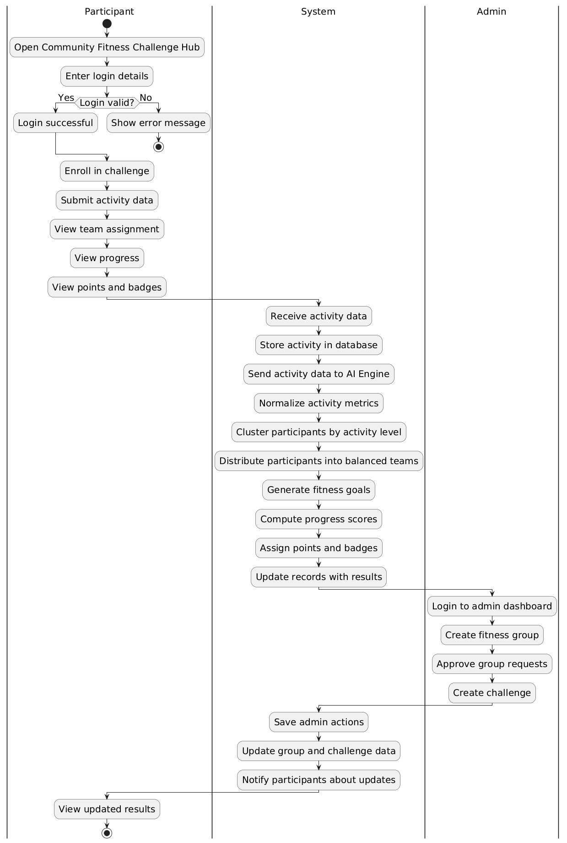
Figure.3 Activity Diagram

